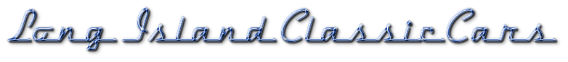
Long Island's On-Line Home for the Classic & Specialty Car Hobby

If you are paying for your ad by check or money order, simply print out this page and mail it to us with your payment enclosed.

We will post your ad once your payment has cleared. Money orders clear as soon as they are cashed. Checks can take up to 7 days depending on the bank. If you have not seen your ad posted within that time frame please feel free to contact us. We give you these direct pay options to make your experience with Long Island Classic Cars a pleasant and efficient one.
Please make checks and money orders payable to "Peter Giordano"
Mail to: Peter Giordano
PO Box 239
Shoreham, NY, 11786.
Be sure to include your e-mail address and the date you submitted your ad on the internet so we may effectively process your payment in conjunction with your ad.
Please print out this page on your computer and write in all the information in the appropriate spaces.
Thank you and happy selling from Long Island Classic Cars!

NAME:__________________________________________
ADDRESS:_______________________________________
CITY:____________________________ STATE:________ ZIP: ________
E-MAIL:_________________________________ PHONE: _______________
Ad Type: Car For Sale___ Services/Business Ad___
Business Ad Size: Small Ad___ Medium Ad___ Large Ad___
Date Submitted on Internet:_____________________________

If you have any questions or need to make any changes to your listing please feel free contact us at questions@liclassiccars.com.
Thank you again! It is your support which helps us build this site and serve the local car community!

